How to change the bow assigned to a setup ArcherySuccess:

Note: In this example we will use the Default Setup and change the Bow assigned to the Setup.
To change the bow or arrows assigned to a setup, on the Gear Tab, tap the setup you want to change.
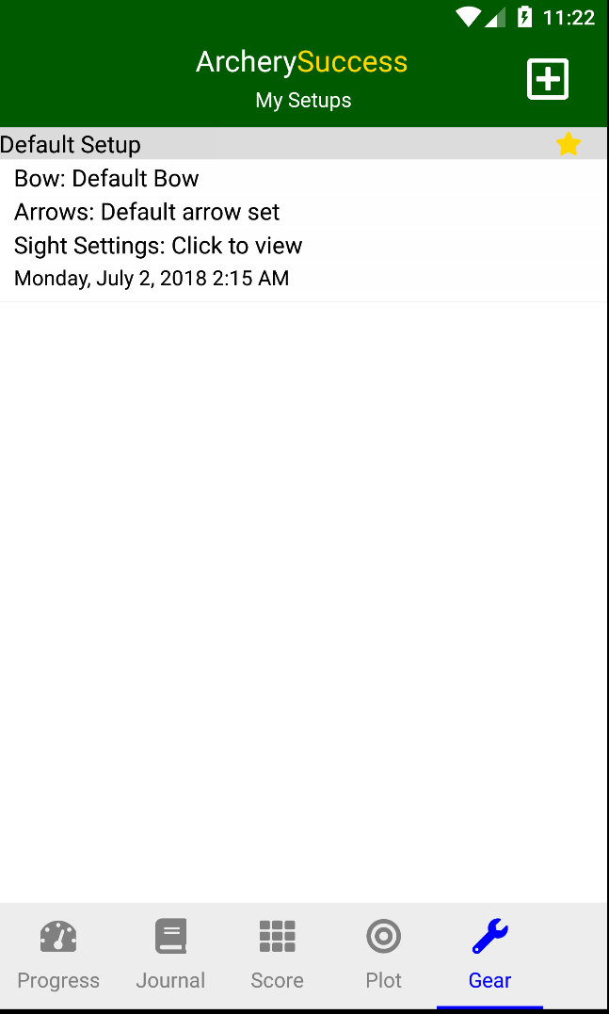

Next the Edit Setup page will be displayed.
Under the Gear item tap Select to navigate to the Select Gear page.
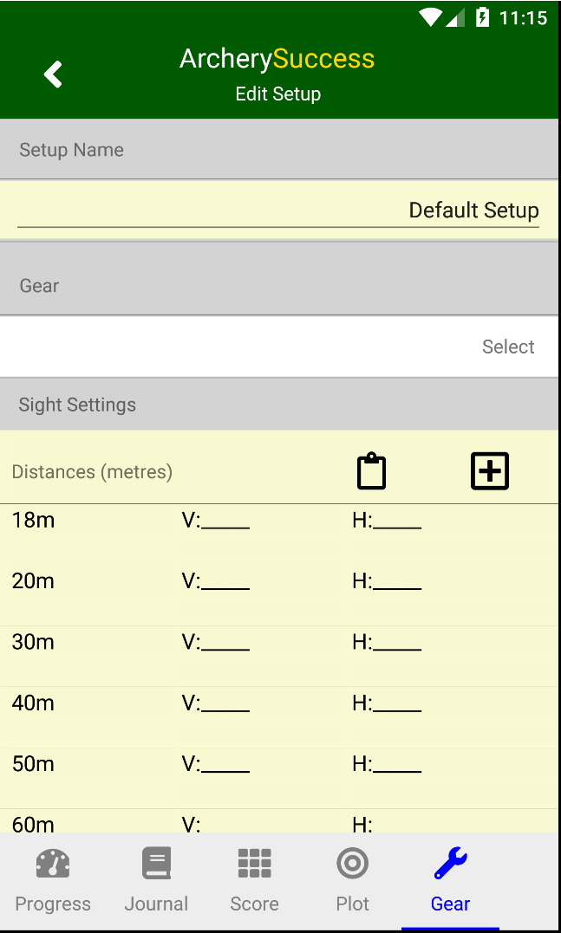

On the select Gear Page you can Change the Bow or Change the Arrows assigned to the setup.
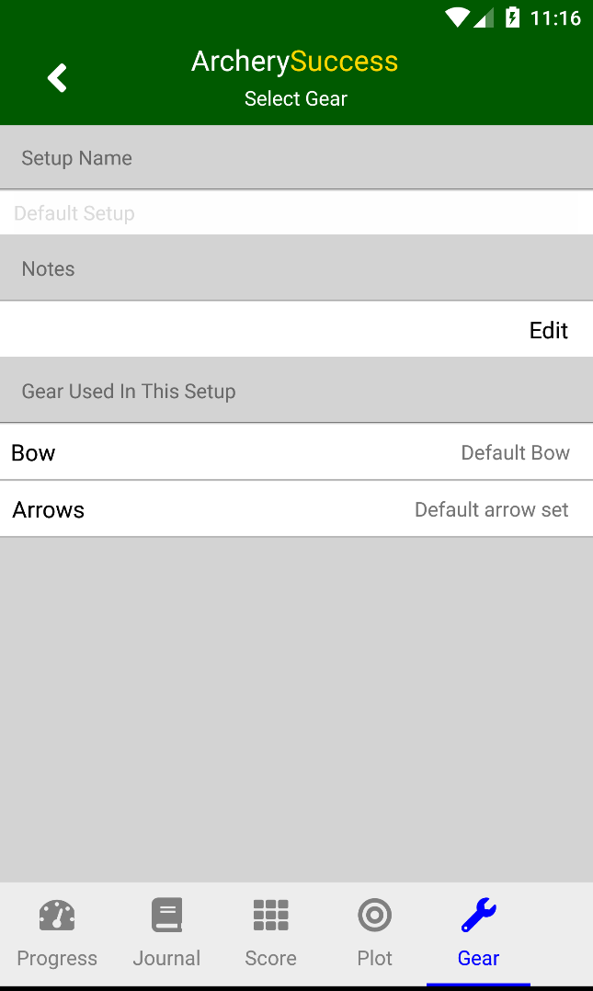
To access the Change Bow or Change Arrows menu item do the following for your phone type.
On Android: Press and hold the Bow Item, this will show a Change Bows menu option at the top of the screen. Tap the Change Bows item. The same step can be done for Arrows.

On iOS: Slide the Bow item to left to show the Change Bows menu option. Tap the Change Bows item. The same step can be done for Arrows.

Next the Select a Bow page is displayed.
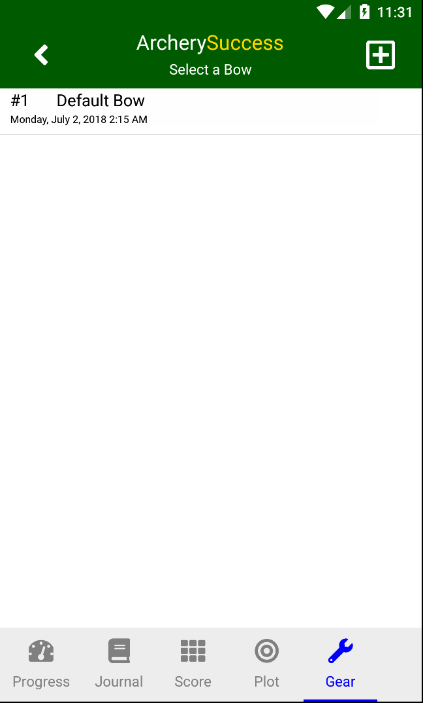
On the Select a Bow page, create a new bow by tapping the new icon, which is as follows:


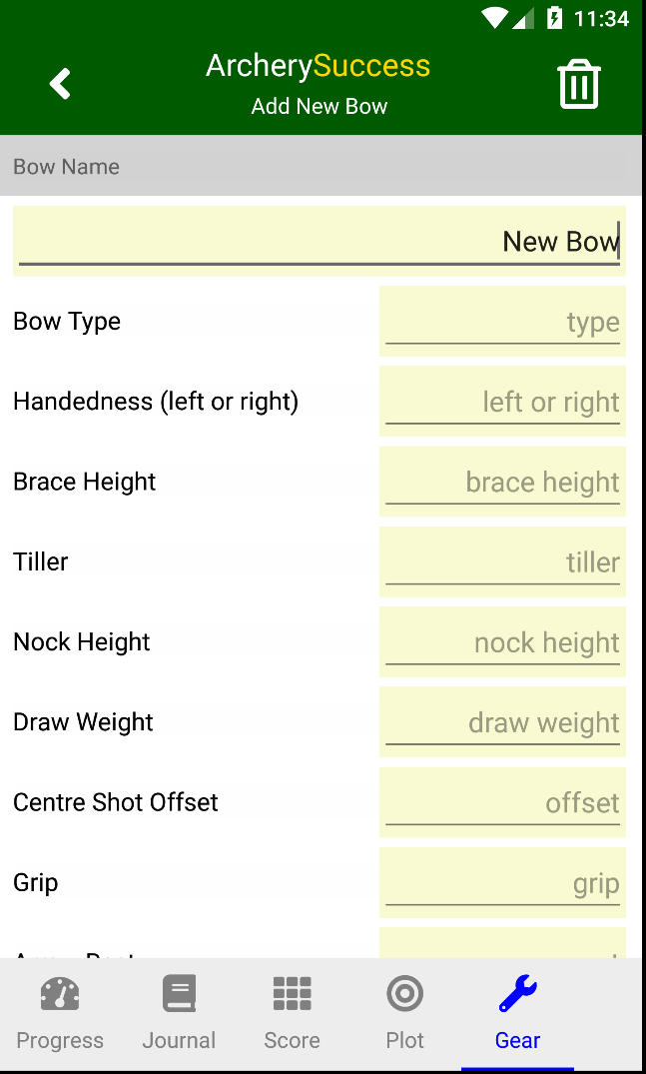

Enter the new bow details and tap the back icon when done to save the bow.


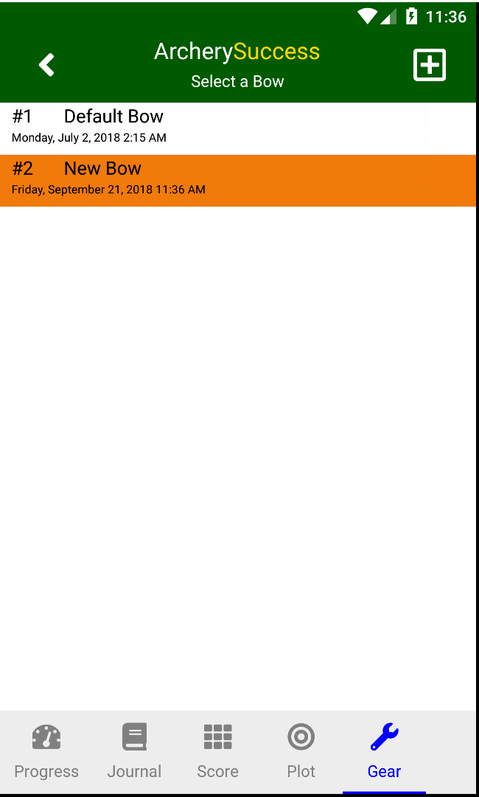

The created New Bow will now appear on the list to select, select the New Bow and click the Back button to assign it to the Gear Setup.

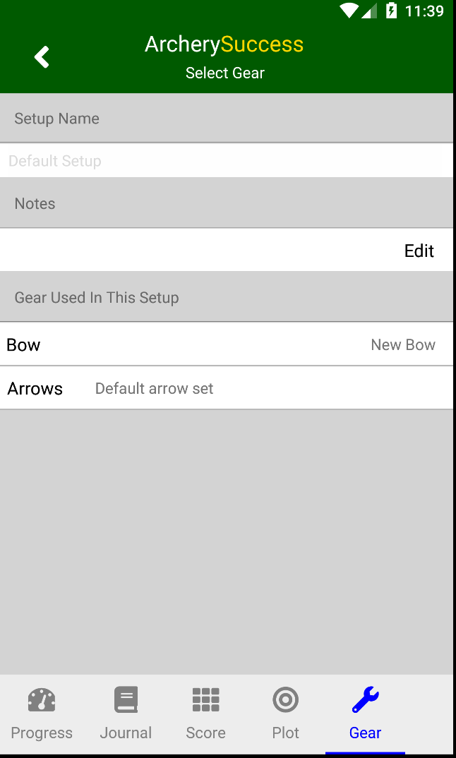

Tap back Twice to navigate back to the My Setups Page.

The New Bow is shown as assigned to the Default Setup.
